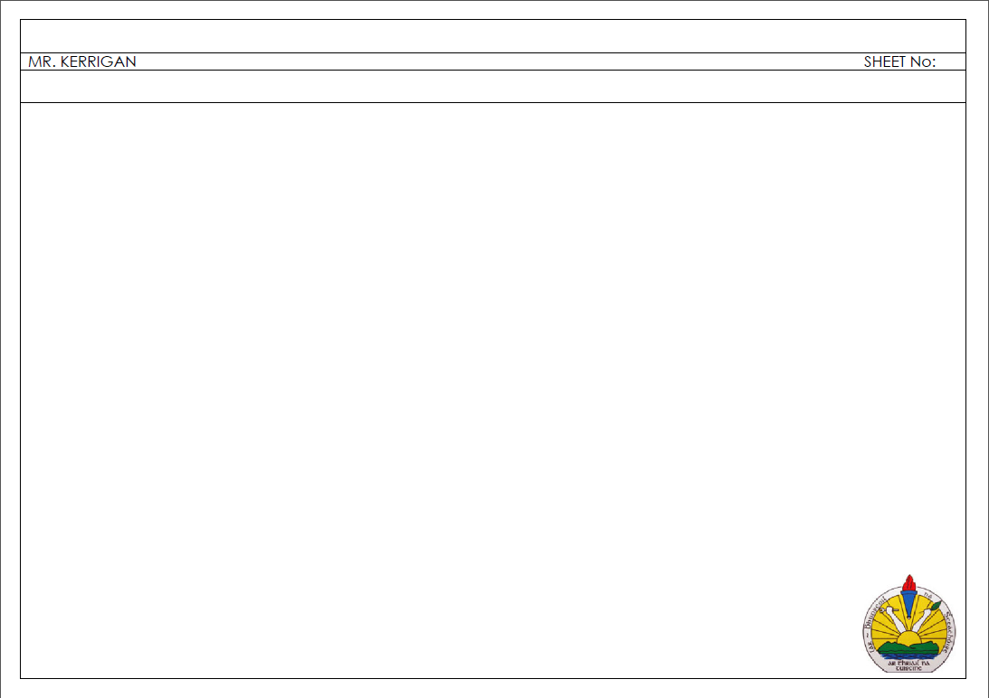

10MM

10MM

DATE

TITLE

NAME:

10 MM

10 MM

10 MM

10 MM

5 MM